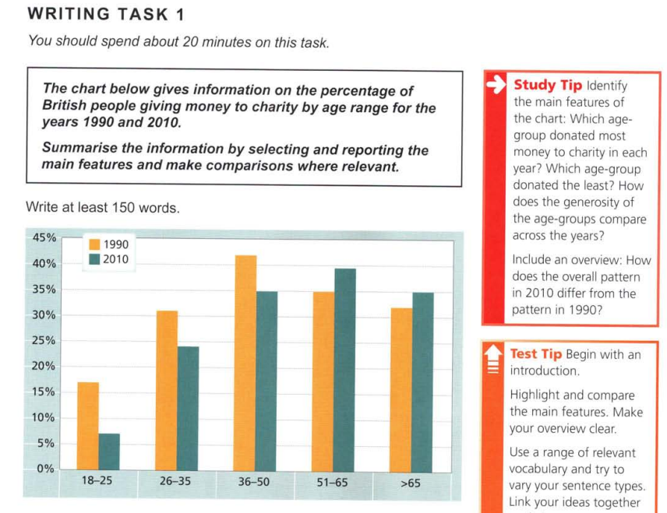

The bar chart shows the proportions of British people giving money to charity by age range for the years 1990 and 2010. In the year 1990, the people of the 36-50 age group donated the most, with around 45% of this group contributing to charities, while younger adults belonging to ages in the range 18-25 donated the least, at about 17%.

The figures for 2010 do not display any drastic changes, except for the fact that the 51-65 group was the leading donor with 39% of the age group being engaged with charity donations. The overall trend of increasing numbers along the younger age groups has stayed the same, with the peak shifting rightward due to the 51-65 group taking the lead in 2010.

A larger observable pattern is the decrease in donors (as a percentage of the population) in the three younger age groups, with the 18-25 group experiencing the steepest decline. The decrease in these age groups is between 5% and 10%. Meanwhile, the older age groups, viz. 51-65 and above 65, have increased in their proportions of donors, both climbing by about 3% to 5% from 1990 to 2010.

In the big picture, we observe that the proportions of donors in Britain have decreased overall, if we make the assumption that the populations of the higher age groups is not substantially higher than the rest.